(Under Construction)

Guide to Descent

Video guide can be found here:

Last Updated : Y2025 - M04 - D

Descent
Descent is a gamemode in which your normal characters gear and weapons are not used, and the run ends when the entire team dies, or you choose to leave. The basic mechanics of a rogue-lite if you are familiar with that.

No progress is saved between runs, but you do gain permanent currency that allows permanent upgrades, making progression easier in subsequent attempts, as more time is spent with the mode, and more permanent unlocks are bought.

The premise is that it is a simulation, and that is why your gear and weapons cannot be used, but yo uget to pick weapons, skills and talents as you go.

Basics of Descent
x

Nemesis Run or Deep Run
The are two main ways that descent is ran, those are :

- Going for the nemesis fight as fast as possible, by going with easy rooms as much as possible to get the nemesis heat quickly and fight the nemesis after loop 4 preferably. This is mostly done to do the weekly project.
- Going deep where we try to accrue as much NSA tech as possible by going for higher loops. This is mostly done for the NSA tech currency and getting reconstructed caches.

Loop

Map
Descent has 2 maps currently, it is random which one you get.

Lab is a map based visually on the DARPA mission, it has opposing spawn points, depending on which spawn you get you will go across to do the boss arena on the other side. Meaning that its 2 layouts are just the same map, but going in different directions.

Bunker is a map based visually on Federal Emergency Bunker, it has one spawn point, and depending on the path taken, will lead into one of two boss arenas.

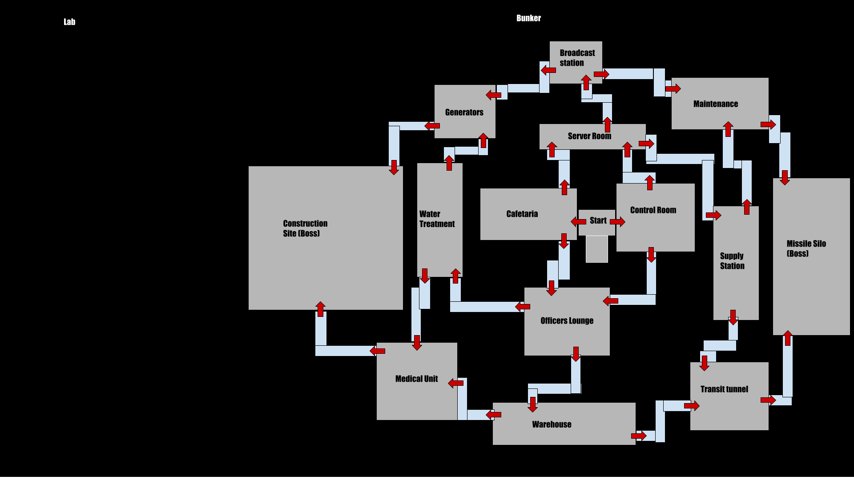
Rooms
(entry circle talent picks)
(Hazards of rooms)

Talent Pool Rotations
The is a talent pool rotation with currently 5 different sets of talent pools, they rotate every 3 days, with each rotation having its own benefits and downsides.

The five talent pools are :
- Envy
- Wrath
- Sloth
- Greed
- Gluttony
They are named after the seven deadly sins, and currently we are missing Lust and Pride

Talents
Descent uses its own talents that are based on the talents of gear and weapons from the normal game, the full list of which can be found here, on the reddit community spreadsheet, under the “Descent Talents” tab:
https://docs.google.com/spreadsheets/d/e/2PACX-1vTJEX5DerCvOj3a_m36TRy1gPBAUvrduOIdmXI9j1Y0MpQk1wIXaZ9KOcPa7HzXzp_N5qGmjDj6yEfL/pubhtml#

You get to pick a talent after completing each room, you will have 3 to pick from each time, with a 4th t can be made available through buying the upgrade.

Damage calculation wise all talents in descent use the same pools for what they add to as the normal game.

(amount of slots)

Exotic Talents
After completing loop 1 by defeating the named enemy in the boss arena, you get to pick an exotic talent. Further picks will randomly be available after further boss arenas.

You can have a maximum of 3 Exotics Talents at a time, and each Talent Pool has 6 exotic talents to pick from.

The chances of receiving Exotic Talent choices on a per loop basis :
1: 100%
2-3: 5%
4-6: 25%
7-9: 35%
9+: 40%

Weapons
Weapons in Descent are based on weapons from the normal game, the pool of weapons is alot smaller as only weapons that have a grey variant are available. Weapons in descent cannot be equipped with weapon mods the way we are able to in the normal game.

At the start of each loop you get to pick from weapons, 3 picks are available from the start, with a fourth being unlocked by buying the upgrade from the start of the loop shop within descent.

Weapons come in 3 rarities within descent, starting with grey/worn out weapons on loop 1, from loop 2 onward green/(?) weapons start to show up, from loop 4(?) onwards blue/specialized weapons become available. The shop will have random weapon picks, and rarity will gradually go up and from loop 8 onwards it is mostly blue weapons with a few green ones still showing up.

Weapons appear to have the same balancing as the normal game, as changes to weapons sofar carry across to inside the gamemode. Making most of the good picks outside also good pick inside.

Also weapons will have 1st and 2nd stats, starting with green items having 1 stats of Weapon damage, and blue weapons have 2 stats with weapon damage and that weapons class stat. These stats within descent are tiny and not of any real consequence.

Skills

Body

Start of the Loop Shop

x

Supply station

Revive token
Body

Early Loops (1-8ish)

Body

Nemesis

Body

Mid Loops (10-25)

Body

High Loops (25+)

Body

Rewards
There are 3 real rewards from the game mode, Reconstructed caches, NSA tech and Apparel Patches. Also some normal XP depending on how far you got.

Reconstructed caches are caches that reward one named item in the same way as named item caches, together with being the only source for a large list of named item blueprints. This list contains almost all of the named items in the game, including all of the dz named items. This allows for easy crafting of them.
The blueprint reward is a non duplicate blueprint, meaning you will eventually have the entire set.

NSA Tech is the currency received from boss arenas, optional boss rooms, and rogue encounters.
It is used to buy permanent upgrades, several apparel items, several cache types including reconstructed and exotic caches, and the vindicator exotic rifle.

For reaching certain milestones, loop 10, 20, 30 and 40, and for beating the nemesis after loop 8, you can receive apparel patches for your armband.

Permanent Unlocks

Body

Envy Setup

Body

Wratch Setup

Body

Apparel Patches

Body

General Tips

Solo,loop 6 two waves, loop 16 elites, loop 17 3 waves,

Links to my other guides, the Build Collection, DMG/DPS Calculators and many other things:

https://docs.google.com/document/d/15mg-_sjowh5_8bUp2VIBqnDxCDqz-xJOISl0DlG3RDU

